|  |
| --- |
| **Reframing Tradition: Investigating the Transformation of Folk Dance into Contemporary Practice** First Author1, Second Author2, & Third Author3  University First Author, Malaysia1 | University Second Author, Indonesia2 | University Third Author, Singapore3  emailaddress1stauthor@email.com1 | emailaddress2ndauthor@email.com2 | emailaddress3rdauthor@email.com3  Corresponding author: emailaddresscorrespondingauthor@email.com Received: Month X, 2025 | Accepted: Month X, 2025 | Published: Month X, 2025 |

## ****Abstract****

This article examines how contemporary performance engages with the everyday as a site of embodied meaning-making. Drawing from performance studies and phenomenological frameworks, the study explores how acts rooted in daily gestures, routines, and social behaviours are aestheticised on stage to question the boundaries between art and life. Using case studies from Southeast Asian experimental performance works, the analysis highlights how the politics of presence, spectatorship, and liveness are negotiated in minimal, non-narrative, and durational formats. The article argues that by amplifying the banal and repetitive, these performances activate critical reflection on bodily labour, temporality, and relationality in public space. **Note:** If your article is written in Bahasa Melayu, please include both the English and Malay abstracts & keywords in your submission.

*Keywords:* embodiment, everyday performance, liveness, performativity, presence, spectatorship

## Introduction

Recent years have seen an increased turn towards the everyday in contemporary performance practice. Artists are staging meals, walking routines, domestic chores, and silences—not as background actions but as central performative events. This shift raises questions about the performative nature of ordinary life and the theatricality embedded in lived experience. Anchored in performance studies, this article explores how the everyday becomes a performative site that reconfigures notions of presence, engagement, and the role of the audience.

## Literature Review

The intersection of everyday life and performance has garnered increasing scholarly attention across the fields of performance studies, anthropology, and visual culture. Influentially, Erving Goffman’s *(1959)* dramaturgical analysis of social interaction provided early groundwork for understanding everyday behaviours as performance. Building on this, Richard Schechner *(2002)* expands the performative frame to include not only theatrical events but also ritual, play, and ordinary action. His proposition that "restored behaviour" constitutes all performance remains foundational to the field.

Fischer-Lichte *(2008)* introduces the notion of the "autopoietic feedback loop," which underscores the dynamic co-creation between performers and audiences in live performance. This model privileges presence, corporeality, and real-time responsiveness as central to contemporary performance’s affective force. Meanwhile, Philip Auslander *(1999)* complicates the binary between live and mediated performance, arguing that liveness is historically contingent and often shaped by technological contexts.

Judith Butler’s theory of performativity *(1990)* further expands the understanding of performance by focusing on the reiterative nature of identity formation through embodied acts. Her work enables a reading of the everyday as a site where social norms are both enacted and potentially disrupted. In relation to Southeast Asia, scholars such as Ngueng (2014) and Chua (2018) have begun articulating how performance practices in the region reflect hybrid temporalities and negotiate colonial residues, modernity, and local cosmologies through subtle, often quiet performative gestures. Contemporary Southeast Asian performance is often marked by slowness, minimalism, or acts of refusal that counter dominant aesthetic expectations. As Khoo (2020) observes in her study of Malaysian postdramatic works, these performances frequently adopt non-linear time and engage the audience through affective proximity rather than narrative structure. The emphasis on stillness, repetition, and banality is not merely stylistic—it forms a critique of productivity and spectacle in neoliberal cultural economies.

This study builds upon these theoretical interventions to examine how the staging of the everyday offers critical insights into presence, temporality, and the ethics of performance in contemporary Southeast Asian contexts.

## Methodology

This study adopts a qualitative interpretive methodology grounded in performance analysis and ethnographic observation. The research seeks to understand how the everyday is recontextualised in contemporary performance through a close reading of selected works by Southeast Asian artists. As performance studies prioritises embodied experience, the methodology integrates analytical, experiential, and reflexive components.

*Selection of Case Studies*

Three contemporary performance works were selected as case studies based on their thematic focus on everyday life and minimalistic aesthetic: Diari Rutin (Malaysia), Lupa Bersuara (Singapore), and Meja Kosong (Indonesia). These works exemplify how Southeast Asian artists utilise repetition, duration, and stillness to stage the quotidian as performance. The selected works span different national contexts yet share conceptual frameworks, allowing for comparative insight.

*Data Collection Methods*

Primary data were collected through three main strategies:

1. Performance documentation: Video recordings of the performances were analysed multiple times to observe spatial design, bodily rhythm, gestural vocabulary, and audience configuration.
2. Semi-structured interviews: The researcher conducted interviews with each of the three choreographers. Questions focused on their creative process, artistic intentions, and interpretation of the everyday. Each interview lasted between 60–90 minutes and was transcribed in full.
3. Audience reflection: Informal post-performance conversations with selected audience members were documented in fieldnotes. These reflections offer insight into modes of spectatorship and affective reception.

*Analytical Approach*

Analysis was conducted using a combination of performance analysis and thematic coding. The researcher employed Laban Movement Analysis (LMA) as an initial tool to examine bodily dynamics and spatial choices. Themes were then inductively generated from interview transcripts and fieldnotes using grounded theory techniques. Analytical attention was given to the politics of stillness, temporality, and proximity as emergent codes. The notion of “presence” was treated both descriptively and theoretically, enabling movement between the empirical and conceptual.

*Positionality and Reflexivity*

As a scholar-practitioner situated within Southeast Asian performance contexts, the researcher acknowledges the influence of positionality on interpretive frames. Field encounters were guided by an awareness of insider-outsider dynamics, linguistic fluency, and cultural proximity. Reflexive notes were kept throughout the research process to trace analytical decisions and to critically engage with assumptions brought into the reading of the works.

## Analysis and Discussion

The three performance works examined—*Diari Rutin*, *Lupa Bersuara*, and *Meja Kosong*—present distinct yet thematically aligned approaches to staging the everyday. Rather than relying on conventional narrative structures, these works focus on bodily repetition, spatial intimacy, and minimal action as performative strategies. The analysis is structured around three interrelated themes: (a) the aesthetics of stillness and repetition, (b) embodied labour and domestic time, and (c) the ethics of co-presence.

The Aesthetics of Stillness and Repetition

In *Lupa Bersuara*, the performer engages in long periods of stillness punctuated by subtle shifts in gaze, posture, and breath. Silence is choreographed not as absence, but as material presence—a performative device that disrupts audience expectations. This resonates with Fischer-Lichte’s (2008) framing of presence as an emergent relation between performer and spectator, where meaning arises not from representation but from the encounter itself. Repetition functions as both aesthetic choice and political gesture. The performer’s refusal to “progress” mirrors a critique of linear dramaturgy and dominant temporalities that govern capitalist cultural production.

Embodied Labour and Domestic Time

*Diari Rutin* foregrounds daily bodily routines—sweeping the floor, folding clothes, eating alone—as choreographic content. These mundane gestures, when displaced from their domestic context and performed under theatrical lighting, shift from functional to symbolic. Butler’s (1990) notion of performativity helps illuminate how such acts, though seemingly trivial, are coded with gendered and social meaning. Here, the female performer’s repetitive labour is not aestheticised for beauty but made visible as a critique of invisibilised domestic work. The performance collapses the boundary between performance and life, challenging assumptions about what qualifies as performative labour.

The Ethics of Co-Presence and Durational Engagement

In *Meja Kosong*, the absence of scripted performance is central. The audience is invited to sit at a table with the performer, sharing space and silence for an extended period. There is no beginning or end, no climactic moment. This durational structure amplifies the experience of waiting, of being-with, and of uncertainty. The performance draws from what Schechner (2002) terms “twice-behaved behaviour,” but removes the spectacle of enactment, replacing it with raw co-presence.

Across all three works, the body operates not as an expressive instrument but as a site of duration, resistance, and presence. A comparative overview of the performances (see Table 1) highlights the differing spatial strategies, temporal structures, and audience configurations employed to activate the politics of the everyday.

Table 1

*Choreographic Features Observed Across Three Performances*

|  |  |  |  |  |  |
| --- | --- | --- | --- | --- | --- |
| **Performance Title** | **Country** | **Dominant Strategy** | **Use of Space** | **Temporal Structure** | **Audience Configuration** |
| *Diari Rutin* | Malaysia | Repetitive daily tasks | Confined, domestic | Cyclical and durational | Proscenium, passive viewing |
| *Lupa Bersuara* | Singapore | Stillness and silence | Isolated spotlighting | Fragmented time | Thrust stage, close range |
| *Meja Kosong* | Indonesia | Shared presence | Table-based circular | Open-ended, durational | Immersive, co-present |

Rather than producing spectacle, these works encourage a slower, more attentive form of spectatorship—one that values presence over performance, duration over drama. This move away from theatrical excess toward embodied minimalism invites reflection on how performance can recalibrate the way we perceive ordinary time, space, and encounter.

*Visual Composition and Embodied Framing*

Beyond movement and structure, visual framing plays a significant role in reinforcing the politics of presence in these performances. In *Diari Rutin*, for instance, the use of tight, overhead lighting creates a visual confinement that mirrors the choreographed labour of domestic life. Meanwhile, *Meja Kosong* employs a circular seating arrangement with soft ambient lighting, creating a flattened visual hierarchy between performer and audience. These visual decisions are not secondary; they construct the atmosphere in which embodiment and relationality unfold. The following image (see Figure 1) illustrates one such spatial and visual configuration from *Meja Kosong*, capturing the intimacy of shared presence in a performance environment stripped of spectacle.

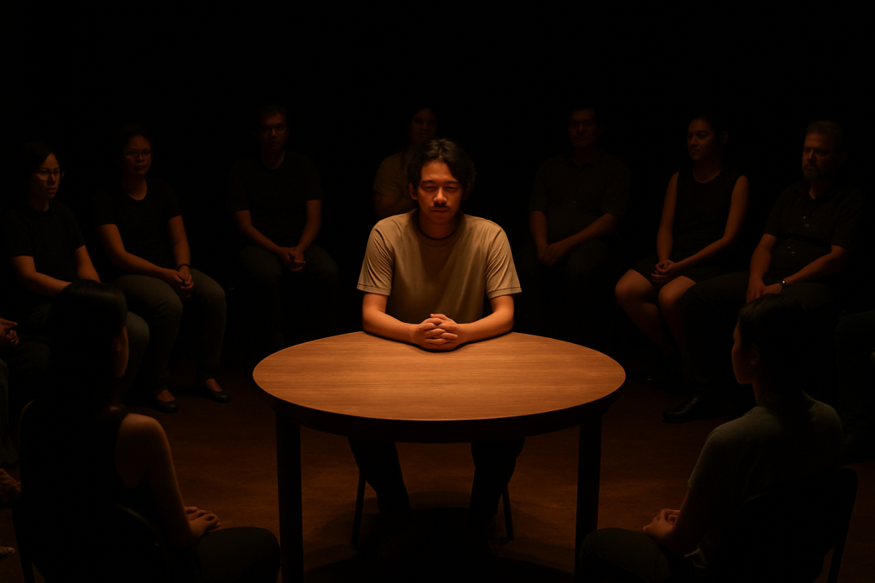

Figure 1: Audience and Performer in Shared Space: Meja Kosong

Description (*if applicable*): A still from the performance showing the performer seated at a round table with audience members on all sides. The lighting is dim and warm, casting soft shadows. The scene captures stillness, with no central action but an atmosphere of attentive waiting.

This visual composition disrupts conventional stage-audience separation and frames performance as a co-experienced temporality. Rather than directing attention to the performer’s body as object, the image suggests a relational configuration in which attention circulates horizontally. The audience, in being placed at the table, is implicated not only visually but ethically, reinforcing the performative shift from spectacle to co-presence.

## Conclusion

The performances analysed in this study illuminate the aesthetic and political potential of staging the everyday. Through stillness, repetition, minimal action, and shared presence, these works resist dominant theatrical logics centred on narrative, virtuosity, and spectacle. Instead, they invite audiences to confront the ordinary not as a void, but as a space of embodied attention and relational intensity. Each work examined—*Diari Rutin*, *Lupa Bersuara*, and *Meja Kosong*—mobilises the mundane to question prevailing assumptions about time, labour, and meaning in performance. What emerges is not merely a representation of daily life but a reconfiguration of how performance itself is understood—as a site of encounter, of ethical witnessing, and of temporal dissonance. These pieces activate a shift in spectatorship: from passive observation to co-presence, from consumption to contemplation. Theoretically, the study draws from performance studies, feminist thought, and phenomenological approaches to foreground the body not as a vehicle for expression but as a site of negotiation—between presence and absence, attention and estrangement, visibility and erasure. In the Southeast Asian context, where cultural performances are often expected to carry symbolic or heritage value, these experimental works complicate the politics of representation by centring the unremarkable. Rather than offering closure, these performances open space for lingering. They invite not resolution, but ongoing reflection on the rhythms of life that often go unnoticed. As contemporary performance continues to evolve, the everyday—when thoughtfully staged—offers a critical resource for rethinking presence, embodiment, and the ethics of encounter. Future research might extend this inquiry by examining how audiences make meaning in such performances, or how digital mediation alters the affective registers of liveness and co-presence.

## Acknowledgements *(if applicable)*

This research was supported by the Southeast Asian Performance Research Grant (SAPRG/2023/019) from the Cultural Studies Research Council. The researcher thanks the choreographers and collaborators for their generous insights, and the audience participants for their reflections. Appreciation is also extended to Universiti Pendidikan Sultan Idris for institutional support.

## References

Name, R. H. (2021). *Book 1: Performing silence in Southeast Asia*. Kuala Lumpur Academic Press.

Name, L. T., & Name, N. A. (Eds.). (2020). *Book 2: The politics of stillness and gesture*. Southeast Asian Theatre Studies Series.

Name, M. K. (2022). Article journal 1: Rethinking everyday presence in minimalist performance. *Journal of Contemporary Performance Theory*, *15*(2), 45–61. https://doi.org/10.1234/jcpt.2022.01502

Name, T. P., & Name, H. M. (2020). Article journal 2: Time, labour, and ethics in durational art. *Performing Arts Review*, *8*(1), 77–93.

Name, Y. R. (2019). *Book 3: Embodied encounters and theatrical absence*. Yogyakarta Performance Studies Press.

# Biography

**First Author** is a senior lecturer at the University First Author, Malaysia. Her research focuses on traditional Malay dance, choreographic transformation, and practice-led methodologies. As a dance practitioner-researcher, she frequently collaborates with community groups to explore how folk dance adapts within contemporary performance ecologies. She has published in regional journals and served as a curator for local arts festivals.

**Second Author** is an assistant professor at University Second Author, Indonesia. His work explores intercultural performance, body politics, and the transmission of indigenous dance forms in postcolonial contexts. He has conducted fieldwork across Southeast Asia and is currently leading a funded research project on archiving endangered dance repertoires.

**Third Author** is a dance scholar based at University Third Author, Singapore. Her research investigates embodiment, liveness, and the aesthetics of minimalism in contemporary dance. She is active in the Southeast Asian performance studies network and regularly contributes to cross-disciplinary dialogues on performance, memory, and urban space.

# PLEASE DELETE THE SECTION BELOW

**Formatting Guidelines – IMPAC Proceedings**

This guide outlines all formatting requirements from top to bottom based on the provided template.

**1. Header Section**

* **Title**: *Proceedings of the International Music and Performing Arts Conference (Vol. 3)*
* **eISSN**: 2773-5745
* **Website**: <https://eprosiding.upsi.edu.my/index.php/Pro-IMPAC/index>
* **Copyright**: © UPSI Press, Sultan Idris Education University, Malaysia
* **Do not make any changes to this section**.

**2. Article Title**

* **Format**: Bold, Title Case (Capitalize Main Words)
* **Alignment**: Centered
* **Font**: Times New Roman, 14 pt

**3. Author Line**

* **Format**: First Author, Second Author, & Third Author
* **Affiliation**: University Name, Country (for author 1) | University Name, Country (for author 2) etc.
* **Emails**: One per author, listed on the next line in order
* **Corresponding Author**: Provide one corresponding author: email@address.com

**4. Article Timeline**

* **Format**: Received: Month X, 2025 | Accepted: Month X, 2025 | Published: Month X, 2025
* **Alignment**: Left
* **Font**: Times New Roman, 9 pt

**5. Abstract**

* **Title**: *Abstract* in bold
* **Font**: Times New Roman, 10 pt
* **Spacing**: Single
* **Alignment**: Justified
* **Language**: If article is in *Bahasa Melayu*, include both English and Malay abstracts
* **No indentation**

**6. Keywords**

* **Title**: *Keywords:* in bold
* **Format**: Lowercase (except proper nouns), comma-separated
* **Order**: **Alphabetical order**
* **Font**: Times New Roman, 10 pt

**7. Body Text**

* **Headings**: Bold, Title Case
* **Subheadings**: Bold, Sentence case
* **Font**: Times New Roman, 11 pt
* **Spacing**: Single
* **Alignment**: Justified
* **Paragraphs**: No indentation (block style)

**8. Tables and Figures**

* **Font**: Times New Roman, 10 pt
* **Tables**:
  + Title above the table: e.g., *Table 1*
  + Use single lines above and below table
* **Figures**:
  + Caption below the figure: e.g., *Figure 1: Title*
  + Include a short description if applicable
  + Visuals must be relevant and clear
* **Cross-referencing:**
  + All tables and figures must be cross-referenced in the text (e.g., *see Table 1, as shown in Figure 2*).
  + Place each table or figure as close as possible to its first mention.
* **Alignment**: Centered or justified appropriately

**9. Acknowledgements**

* **Optional**
* **Format**: Paragraph form, no bullet points
* **Font**: Times New Roman, 11 pt
* **Placement**: After conclusion, before references

**10. References**

* **Title**: *References* in bold
* **Format**: APA 7th edition
* **Order**: Alphabetical by author's last name
* **Font**: Times New Roman, 10 pt
* **Indentation**: Hanging indent
* **Spacing**: Single within, one line between entries

**11. Author Biography**

* **Title**: *Biography* in bold
* **Format**:
  + Each author's biography written in one paragraph
  + **Author's name must be in bold** at the beginning of their paragraph
  + Tone: Academic, include current role, affiliation, area of expertise, research interests
* **Font**: Times New Roman, 10 pt
* **Alignment**: Justified

**12. General Notes**

* **Language**: English OR Bahasa Melayu
  + If in Malay, include both Malay and English **abstracts and keywords**
* **File format**: Microsoft Word (.docx)
* **Do Not Include**:
  + Footnotes
  + Numbered headings
  + ORCID unless requested
  + PDF submissions